Leavers Book  Think about your time at North Tawton Primary School. What are your best memories? What have you learnt in your time there? Which members of staff will you remember? What lifelong friendships have you made? Draft what you would like to write in your page for the Leavers’ Book.  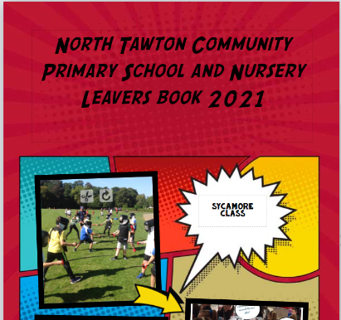 | Science/Art  Living things and their habitats.  Draw an animal in its habitat or create a diorama.  This website may give you some ideas  https://www.generationgenius.com/activities/habitats-activity-for-kids/  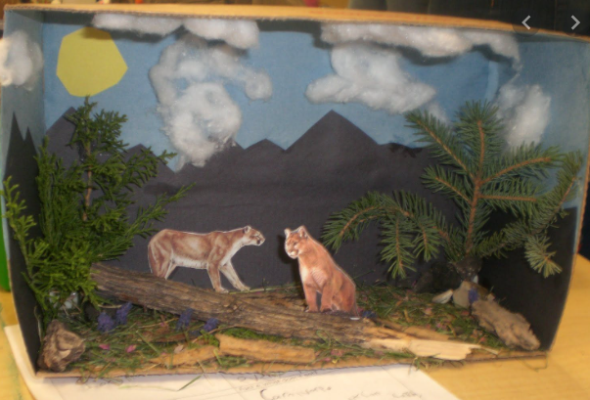 | Geography  The Local Area  Take a walk around your local area; use drawings or photographs to create an information leaflet about your local area. Who lives here? What jobs do people do here? What leisure activities are available? What geographical features are there? What is special about your town/village?
Design and Technology  Playgrounds  Design a playground for the future  Or  design and make a prototype of a piece of playground equipment you wish you could have at your school or in your local park.  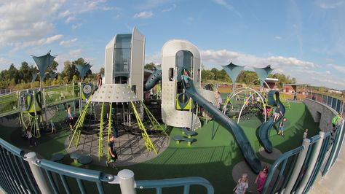 |  | Computing  Variables in a game.  Following one of our computing lessons see if you can create a game which uses variables.  https://scratch.mit.edu/
Maths
Use Timestable Rockstars. You should do your absolute best to have learnt or improve your recall speed of all the tables up to 12 x 12 before the end of primary school.
https://ttrockstars.com/
Please complete at least 3 of these tasks before the end of term. I will also set some revision homework each week leading up to assessment week (28th June) as well as 10 spellings each week. I also expect you to be reading every day and recording this in your reading diary.

