Earth Day was on Thursday 22nd April. Complete one of the activities from the Pobble Lesson I have sent you.  https://app.pobble.com/pupil-auth  You could also find out about UNICEF’S 17 global goals for sustainable development.  http://worldslargestlesson.globalgoals.org/  Visit this website to find out about them.  Choose one of the global goals and make a project to persuade others to make a change to help.  You could make a poster, write a letter, create an advert, write a poem, write a song … | Science  The circulatory system  http://www.tenalpscommunicate.com/clients/siemens/humanbodyOnline/  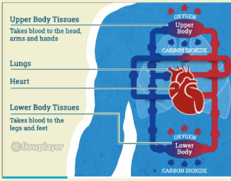  Look at the circulatory system using this online simulation. Use it to create a fact sheet, slideshow or poster about some of the things you have learnt. | History  Ancient Civilisations  Research one of the seven Ancient Wonders of the World.  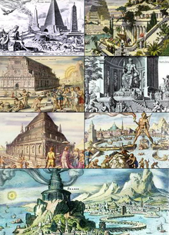  Make a presentation about it. Who built it? Why? Where? How? Is it still standing? What did it look like? What was it used for?
Science  Healthy Lifestyles  Design and make a healthy balanced meal and bring in a photograph or draw and describe the meal you would make.  https://www.foodafactoflife.org.uk/7-11-years/healthy-eating/interactive-resources/  Use the interactive resources on this website to help you.  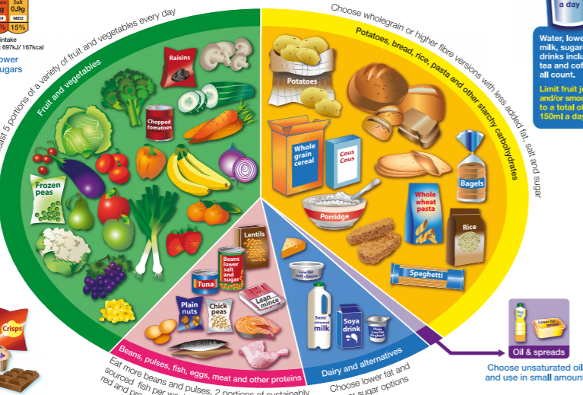 | 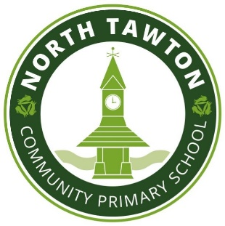 | French  Find out about a French town and make a tourism leaflet persuading people to visit it.  You could also find the recipe for and make something from the town’s local cuisine.  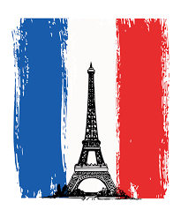  (Take photos to hand in)
Maths
Use Timestable Rockstars. You should do your absolute best to have learnt or improve your recall speed of all the tables up to 12 x 12 before the end of primary school.
https://ttrockstars.com/
Please complete at least 3 of these tasks before the end of half term (28th May) .I will also set some revision homework every other week as well as 10 spellings each week. I also expect you to be reading every day and recording this in your reading diary.

