This term, we are studying Sound in Science. Here are some fun experiments to try at home.  https://youtu.be/ivSS0Q8J5LY?si=wWukKqtejIAXloPY  https://www.twinkl.co.uk/blog/science-experiments-to-explore-sound-for-kids  If you can, take some photos, or maybe even a video and send it to me via Dojo to show yourself at work.  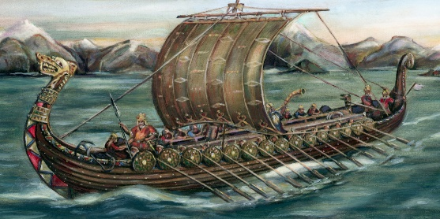 | In History, we are studying the Vikings  We know that the Anglo Saxons believed in many gods, they were polytheistic.  You can choose to either create your own Viking God/Goddess and tell their story within a fact-file.  Or you could create your own set of Top Trumps based on Viking Gods.  Failing this, if you are feeling very creative, try one of the following:  Build a Viking Longboat  https://youtu.be/UvbKLUW3P40?si=_LBEKQIPzH6hT0Qk  Design and make your own Viking weapons:  https://youtu.be/WXFUSAW7LV4?si=wBe-noBnRlvS4d8B |  | Recommended read: We are really focusing on reading, for this I will give the children a recommended read sheet, which works like a book review in part and will be used to help children in the class choose exciting books that their peers have already read.
In P.E. this term, we will be studying net and racket games and Athletics.  This year 2024, the Summer brings us two fantastic competitions: Euro 2024 and the Olympic Games.  I am looking for children’s ideas as to how we could improve Sports Day this year – could it be Olympic themed? Can you design a Sports Day program of events and a map of how it will be laid out. Remember what Year 5 and 6 children can do, will be very different to what Reception children can do, have this in mind when you design your day – we usually have separate KS1 and KS2 activities.  LET’S GET ACTIVE! |  | In art, we are studying landscapes and comparing and contrasting the work of different artists. One of the artists that we will study if Paul Cezanne. Could you either produce your own work in a Cezanne style, or recreate one of his works and bring it in?  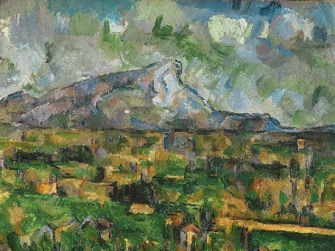  https://youtu.be/p-5pLKTh3xY?si=1AG6L1Zoj5F9_KTP
These tasks will require you to do some research and to present your findings in different ways. For example you could write a report, create an information booklet, make a poster or even record your own documentary! There are also opportunities to respond using artwork or even in 3d. Be as creative as you like but produce a variety – not the same thing each time. Please complete at least 1 of these tasks before the end of this half term. I would like them in by Thursday 23rd May.

