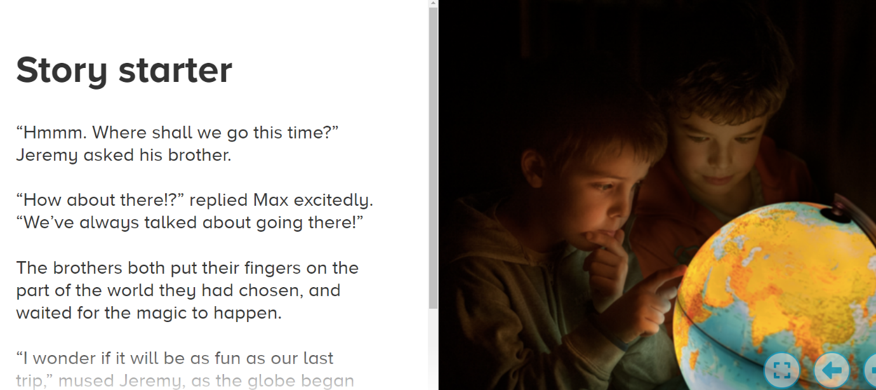
Suddenly, a child-sized portal opened on the wall of their bedroom. Max grasped Jeremy’s hand. Once again, they both walked through this rip in space and time to their desired destination…
Locations all over the world whizzed past the boys' faces. Then, all of a sudden, they fell through another opening. Max and Jeremy landed on their faces in the middle of Africa. Tall twisted trees towered above them. A herd of cattle grazed ahead, munching on dead grass. A small meerkat stood tall above its kingdom of dirt and tunnels. But then, a rattlesnake vibrated its tail behind them.
By Matthew

