**Art**

Photography

**Design and Technology**

Automata toys

**Music**

Music and Me

Reflect, Rewind, Replay

**Physical Education**Cricket

Athletics

Rounders

Lacrosse

**P**ersonal**S**ocial**H**ealth**E**ducation and **R**elationships and **S**ex **E**ducation  
Physical health and Mental wellbeing  
Growing and changing  
Keeping Safe  
**Religious Education**For Christians, what kind of king was Jesus?  
How does faith help people when life gets hard?

**Computing and E-Safety**

**Data and information**

Spreadsheets

**Programming**Variables in games using Scratch

**Maths:**   
Ratio and proportion  
Statistics  
Geometry and property of shapes  
Consolidation and themed projects

**History: Comparing ancient civilisations.**  
This enquiry provides an overview of the following Ancient Civilisations – Egypt, Sumer, Indus Valley and Shang, showing where they developed, when they developed, the similarities between them and how they relate to a broadly based chronological understanding of the past.

**Geography: The local area and region.**

This six-week Scheme of Work uses fieldwork to investigate the region local to our school. Pupils begin

by exploring the area’s location and its links to the wider world, before using road maps to investigate

key features within a fifty-mile radius of the school.

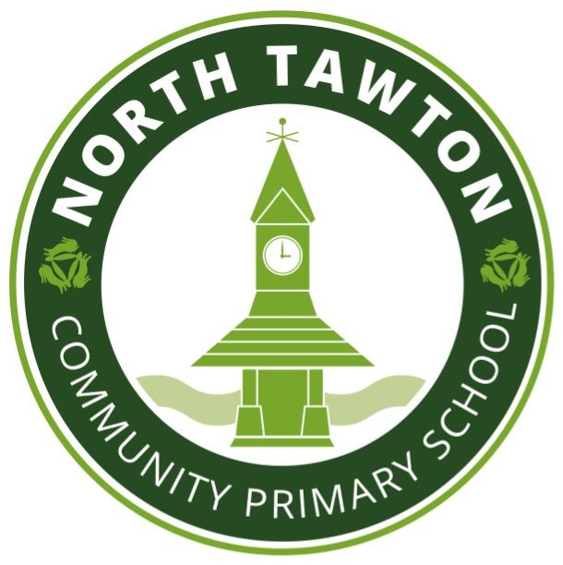

**Science:  
Animals including humans:**Children will build on their learning from years 3 and 4 about the main body parts and internal organs (skeletal, muscular and digestive system) to explore and answer questions that help them to understand how the circulatory system enables the body to function. They will learn how to keep their bodies healthy and how their bodies might be damaged – including how some drugs and other substances can be harmful to the human body.   
**Living things and their habitats**

Children will describe how living things are classified into broad groups according to common observable characteristics and based on similarities and differences, including micro-organisms, plants and animals.

**English Texts for writing**

**Anatomy: Non-Fiction***Children will write a page of an information text***The Story of Antigone: Narrative***Children will write a chapter of the story***Animalium: Non-Fiction***Children will contribute to a class book about animals***Cloudbusting: Poetry***Children will tell a story through poetry*

**Modern Foreign Languages  
French**Planning a holiday in France

A French Town

**Class: Sycamore**

**Year Group: 6**

**Summer Term 2021**