This term, we are studying Magnetism, we had some fantastic scientific chefs last term, who sent in some great videos of themselves experimenting in the kitchen. This term, using the attached link for ideas, you could either video yourself experimenting as your alter – ego Professor……? Or produce a photo story board of you carrying out the experiment(s).  https://camp.com/articles/magnet-experiments-for-kids  R.E.: The 2 key religions in the Middle East are Christianity and Islam. Both of these religions have rules and ideas that underpin them. Islam has the Five Pillars and Christianity has the 10 Commandments. Can you look at the ideals and then think about a set of 8 ideals that you would use to base your own religion on. You will need to give your religion and your rules/ideals a name and you will also need to create a symbol that represents your religion. | The Middle East  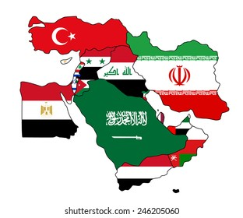  We have been looking at different types of poetry in English. Can you research what a Limerick is and write 2 to include in your own poetry anthology.  (See the pdf on Dojo for help with this) |  | In our class novel, Room 13 by Robert Swindells, the story is based around a class residential to Whitby in Yorkshire. The main character Felicity has a strange recurring dream about Room 13 and a hypnotic power that controls her feet, taking her to the room and what is inside. We established that this is from the Horror genre with an element of mystery. Could you write a story that has a mystery waiting to be solved it could be North Tawton based, maybe on a local building such as The Clink or The old Wool Mill.
Music: in Music this term, the children are studying Electro-Pop. Can they either, create a poster explaining what Electro-Pop is, create an Electro-Pop style album cover, or if you are feeling really creative, there is a free app called Groove pad, that you can use to create and record your own Electro-Pop track.  Food/DT: The Middle East is famous for its cuisine. Could you research Middle Eastern cuisine and create your own restaurant, designing a menu and giving your restaurant a name and logo. Or, could you find a Middle Eastern inspired recipe that you can recreate in the kitchen and enjoy with your family (video or pictures and a copy of the recipe would be brilliant for this). |  | Can you create your own piece of artwork, based on the artist that we have been studying – Pablo Picasso.  You could create your own faces based on the Picasso Cubist style – see the following link for ideas: https://www.artycraftykids.com/art/picasso-faces-easy-art-for-kids/  Alternatively, as we are studying the Middle East, one of Picasso’s most famous paintings is Guernicca, based on the Spanish Civil War of 1939. Could you creat your own version of Guernicca, based on the conflict in the Middle East, either historical (The Crusades) or current Israeli-Palestinian issue.
These tasks will require you to do some research and to present your findings in different ways. For example you could write a report, create an information booklet, make a poster or even record your own documentary! There are also opportunities to respond using artwork or even in 3d. Be as creative as you like but produce a variety – not the same thing each time. Please complete at least 3 of these tasks before the end of this half term. I would like them in by Thursday 17th February.

