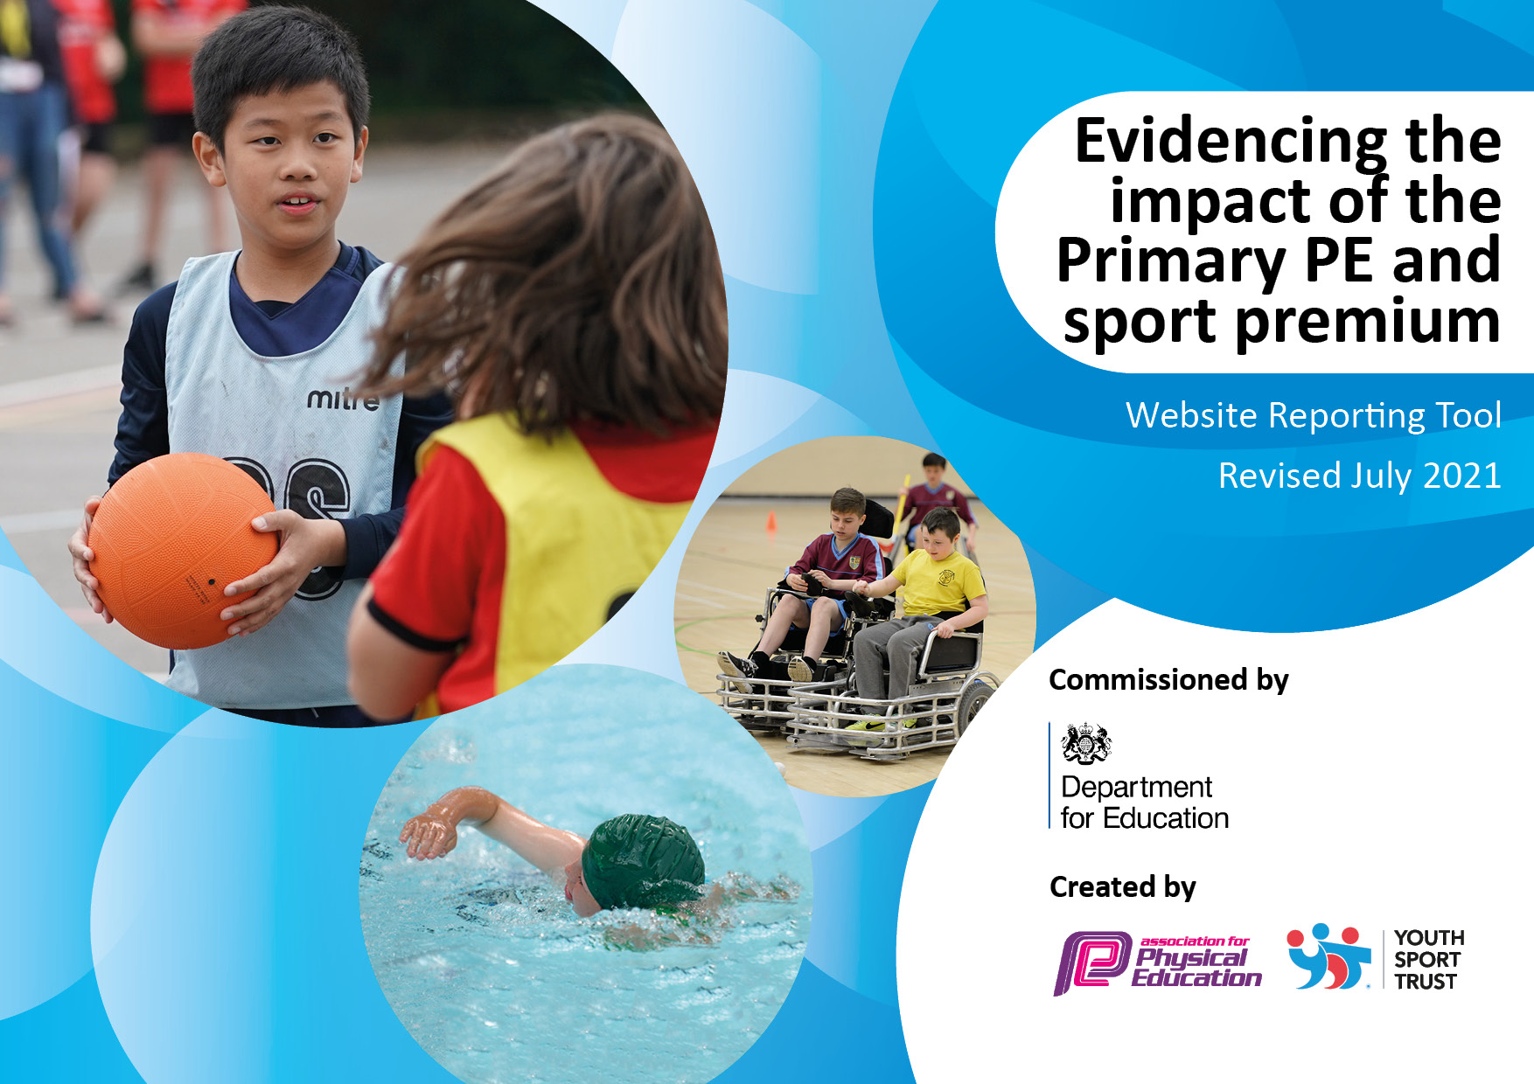
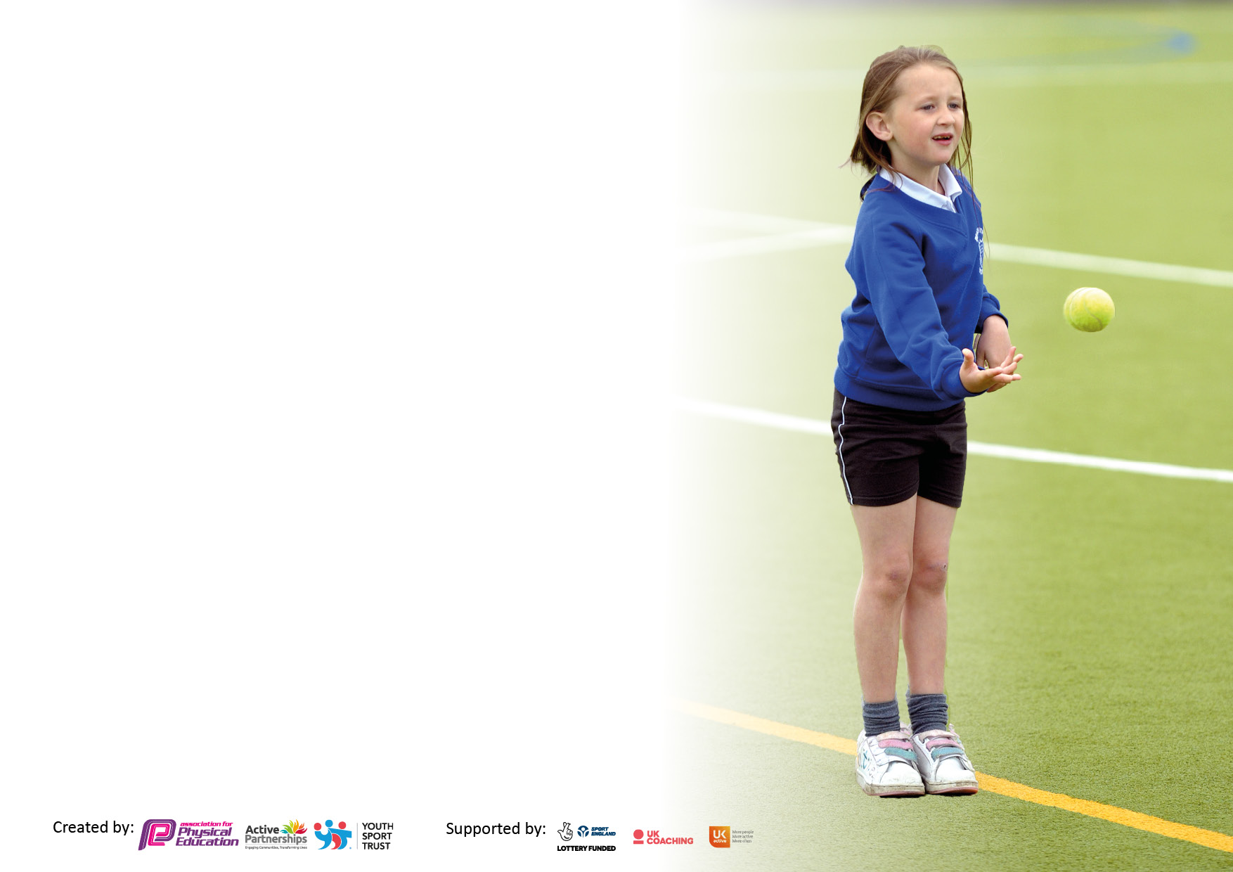

It is important that your grant is used effectively and based on school need. The Education Inspection Framework makes clear there will be a focus on ‘whether leaders and those responsible for governors all understand their respective roles and perform these in a way that enhances the effectiveness of the school’.

Under the Quality of Education Ofsted inspectors consider:
Intent - Curriculum design, coverage and appropriateness
Implementation - Curriculum delivery, Teaching (pedagogy) and Assessment
Impact - Attainment and progress

To assist schools with common transferable language this template has been developed to utilise the same three headings which should make your plans easily transferable between working documents.

Schools must use the funding to make additional and sustainable improvements to the quality of Physical Education, School Sport and Physical Activity (PESSPA) they offer. This means that you should use the Primary PE and sport premium to:

- Develop or add to the PESSPA activities that your school already offer
- Build capacity and capability within the school to ensure that improvements made now will benefit pupils joining the school in future years
- The Primary PE and sport premium should not be used to fund capital spend projects; the school’s budget should fund these.

Pleasevisitgov.ukfortherevisedDfEguidanceincludingthe5keyindicatorsacrosswhichschoolsshoulddemonstrate animprovement.Thisdocumentwillhelpyoutoreviewyourprovisionandtoreportyourspend.DfEencouragesschools to use this template as an effective way of meeting the reporting requirements of the Primary PE and sport premium.

We recommend you start by reflecting on the impact of current provision and reviewing the previous spend.

Schools are required to publish details of how they spend this funding, including any under-spend from 2019/2020, as well as on the impact it has on pupils’ PE and sport participation and attainment. All funding must be spent by 31st July 2022.

We recommend regularly updating the table and publishing it on your website throughout the year. This evidences your ongoing self-evaluation of how you are using the funding to secure maximum, sustainable impact. Final copy must be posted on your website by the end of the academic year and no later than the 31st July 2021. To see an example of how to complete the table please click HERE.

Details with regard to funding
Please complete the table below.

Total amount carried over from 2022/23 | 0
Total amount allocated for 2023/24 | £17450
How much (if any) do you intend to carry over from this total fund into 2025 | 0
Total amount allocated for 2023/24 | £17450
Total amount of funding for 2022/23. To be spent and reported on by 31st July 2023 | £17450
Swimming Data
Please report on your Swimming Data below.

Meeting national curriculum requirements for swimming and water safety.

N.B. Complete this section to your best ability. For example you might have practised safe self-rescue techniques on dry land which you can then transfer to the pool when school swimming restarts.
Due to exceptional circumstances priority should be given to ensuring that pupils can perform safe self rescue even if they do not fully meet the first two requirements of the NC programme of study
What percentage of your current Year 6 cohort swim competently, confidently and proficiently over a distance of at least 25 metres?  N.B. Even though your pupils may swim in another year please report on their attainment on leaving primary school at the end of the summer term 2022.  Please see note above | 2022 cohort. 83% July 2022
What percentage of your current Year 6 cohort use a range of strokes effectively [for example, front crawl, backstroke and breaststroke]?  Please see note above | %
What percentage of your current Year 6 cohort perform safe self-rescue in different water-based situations? | %
Schools can choose to use the Primary PE and sport premium to provide additional provision for swimming but this must be for activity over and above the national curriculum requirements. Have you used it in this way? | Yes/No

Action Plan and Budget Tracking
Capture your intended annual spend against the 5 key indicators. Clarify the success criteria and evidence of impact that you intend to measure to evaluate for pupils today and for the future.

Academic Year: 2022/23 | Total fund allocated: | Date Updated: Jan 2023
Key indicator 1: The engagement of all pupils in regular physical activity – Chief Medical Officers guidelines recommend that primary school pupils undertake at least 30 minutes of physical activity a day in school |  |  |  | Percentage of total allocation:
Intent | Implementation |  | Impact
Your school focus should be clear what you want the pupils to know and be able to do and about  what they need to learn and to  consolidate through practice: | Make sure your actions to achieve are linked to your intentions: | Funding allocated: £1600 | Evidence of impact: what do pupils now know and what can they now do? What has changed?: | Sustainability and suggested next steps:
Young Sports Leaders (YSL):  Involving children from both key stages in physical activity at play and lunchtime.  Giving all Year 6 children the opportunity to take responsibility and gain experience of leading. | Jackie Jarvis to provide training to Year 6 in Jan 2023. | Included in OCRA  Membership £1600 | The YSL will show that they can lead activities for younger children with confidence. Improved communication skills, self-esteem and they are able to impart knowledge to support others. Increases percentage of active children. | Current Year 6 children could provide workshop on being a YSL to current Year 5s before they leave to set the next group up to take on the role.  Year 6 to plan and organise event for younger children.
Daily Dash/Exercise/ Active breaks, to maximize outdoor time and impact on wellbeing, both physical and mental. | Every class to include daily dash, movement breaks/active breaks in their daily timetable. |  | Children are becoming increasingly more confident and able to run further in the given time.  Children to use during break times and staff to incorporate into lessons as active starters or learning opportunities. | Personal challenges around the daily dash e.g. number of laps in a set time.
A range of playground equipment available to children of all ages, to encourage active playtimes. | HA to order and Sports Leaders take responsibility for it. | (FONTs Funded) | All children will get to try out different equipment, improving the quality of their playtimes and encouraging them to be active.
Key indicator 2: The profile of PESSPA being raised across the school as a tool for whole school improvement |  |  |  | Percentage of total allocation:
Intent | Implementation |  | Impact
Your school focus should be clear what you want the pupils to know and be able to do and about  what they need to learn and to  consolidate through practice: | Make sure your actions to achieve are linked to your intentions: | Funding allocated:  £12500 | Evidence of impact: what do pupils now know and what can they now do? What has changed?: | Sustainability and suggested next steps:
Continue to embed Real PE, Real Foundations and Real Gym and ensure all staff are trained. | Continue with Real Legacy programme to achieve progression across the year groups and develop positive attitudes towards physical activity amongst the children. | £5500 | Feedback from staff and pupils on quality of lessons and skills taught.
Southwest Saints Coaches provide specialist coaching across a range of sports for all classes across the school.  Teachers to observe throughout the year as part of their PE CPD. | Discuss planning with teachers, and the sports, they would like taught throughout the year. Ensure this works with the Real PE lessons taught by teachers.  Create timetable for each half term – rotating classes. | £7000 | Range of sports taught across the school. Feedback from Saints coaches and children. Staff observe and participate in high quality PE lessons and begin applying skills to their own lessons. | Planning and assessment to be provided by Saints coaches. Feedback from class teachers.

Key indicator 3: Increased confidence, knowledge and skills of all staff in teaching PE and sport |  |  |  | Percentage of total allocation:
Intent | Implementation |  | Impact
Your school focus should be clear | Make sure your actions to | Funding | Evidence of impact: what do | Sustainability and suggested
what you want the pupils to know | achieve are linked to your | allocated: | pupils now know and what | next steps:
and be able to do and about | intentions: |  | can they now do? What has
what they need to learn and to |  |  | changed?:
consolidate through practice:
Teaching of sport and PE in school is judged to be at least good with clear tracking and assessment leading to clear progress and attainment for all pupils in line with national expectations. | Regular, high quality CPD given and tailored to staff needs, SAINTs coach employed to work with each member of staff for 1 hour a week  Real PE training for all teaching staff and continued support through Real Legacy. |  | Staff are confident to teach all areas of the PE curriculum and feel supported when they do
Learning walks evidence the physical activity also taking place within lessons | Regular Learning Walks
Key indicator 4: Broader experience of a range of sports and activities offered to all pupils |  |  |  | Percentage of total allocation:
 |  |  |  | 5%
Intent | Implementation |  | Impact
Your school focus should be clear | Make sure your actions to | Funding | Evidence of impact: what do | Sustainability and suggested
what you want the pupils to know | achieve are linked to your | allocated:  £1100 | pupils now know and what | next steps:
and be able to do and about | intentions: |  | can they now do? What has
what they need to learn and to |  |  | changed?:
consolidate through practice:
Maintain and invest in equipment to explore new sports, both indoors and out. | Audit equipment | £800 | Children will have the opportunity to access a range of sports and try out different equipment.
Engage more children and families in activity, with particular emphasis on those ‘inactive’ children. | Member of staff trained in Real Play.  Attend events targeting these children. | £300 – transport and cover | Targeting inactive families. Take feedback from parents. Complete active questionnaire before and after RealPlay, part of Real Legacy, which will be funded from underspend. | Real Play for targeted families.  PE homework/challenges set by PE Lead.  PE Lead to share ideas/run activities.
OCRA membership – provides the children with various sporting festival and coaching across both KS1 and KS2. | Ensure all staff have a copy of the events calendar. | (£1600 – as above) | All children experience quality coaching and a broad range of sports.

Key indicator 5: Increased participation in competitive sport |  |  |  | Percentage of total allocation:
 |  |  |  | %
Intent | Implementation |  | Impact
Your school focus should be clear | Make sure your actions to | Funding | Evidence of impact: what do | Sustainability and suggested
what you want the pupils to know | achieve are linked to your | allocated: £1600 | pupils now know and what | next steps:
and be able to do and about | intentions: |  | can they now do? What has
what they need to learn and to |  |  | changed?:
consolidate through practice:
OCRA membership allows opportunity for competition across a range of sports. | Participate in as many inter school competition as possible and ensure intra-school competition is delivered in PE lessons. | (£1600 as above)  £1000 transport  £600 supply/cover | All children have the opportunity to take part in some competitive sport. Develop communication, growth mindset, resilience and team skills.

Signed off by
Head Teacher:
Date:
Subject Leader:
Date:
Governor:
Date:

