Art  Research and learn about the famous artist Pablo Picasso.  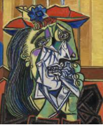  You could choose to create a factfile, recreate a famous painting, create a leaflet about 3 of his famous paintings or create a Powerpoint about him and his works. | Science - Sustainability  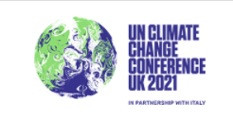  ● Visit www.cup26.co.uk  ● Register your details, choosing your favourite (or local) football club to represent  ●Register and complete the range of activities at home with your family  Take some photos and send them in to share with the class.  Or:  Can you create a poster which shows people the importance of being environmentally friendly? Try to persuade people to act in a more sustainable way. |  | English - Reading  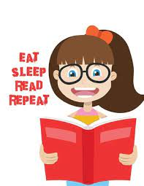  Read every day for 10 minutes or longer. Remember to record your reading in your reading diary.  Choose a reading response activity from the menu in your homework folder and complete at least one this half term.
French –Francophone countries
Make a poster to show all the different countries where France is one of the official languages spoken.
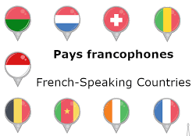

English- Writing  Write a poem for Remembrance.  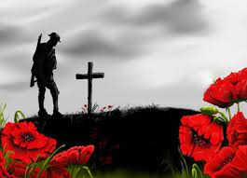 | Autumn 2  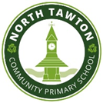 |  |  | Maths  Weekly practice of times tables.
Weekly practice of Spellings  Practise your spellings by:  - Making a word search or crossword  - Writing a short story including all the words  - Handwriting practise using your words  - Pyramid words  - Look, cover, copy, check |  | 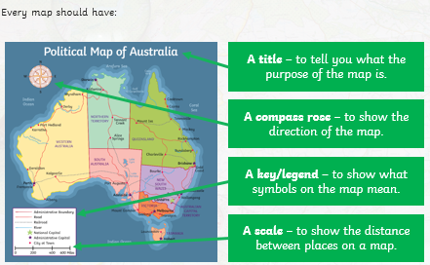  Geography  Draw a detailed map of either: a country of your choice, a county of your choice, the local area or a place from your reading book.
These homework tasks will require you to do some research and to present your findings in different ways. Be as creative as you like but produce a variety – not the same thing each time. You will need to choose and complete at least three of the tasks as well as daily reading, regular spelling and times table practice.

